|  |  |  |
| --- | --- | --- |
| **Number** | 16 | |
| Name | Remove a comment | |
| **Summary** | Administrators and moderators can remove comments. | |
| **Priority** | 4 | |
| **Preconditions** | The comment exists and the user removing the content is either an administrator or a moderator. | |
| **Postconditions** | The comment is removed from the database. | |
| **Primary Actor** | Administrator / Moderator | |
| **Secondary Actors** | Comment, User who posted the Comment | |
| **Trigger** | Administrator / Moderator clicks on the “remove comment” icon next to a comment. | |
| **Main Scenario** | **Step** | **Action** |
|  | 1 | “Remove Comment” icon is clicked. |
|  | 2 | The administrator / moderator is prompted to confirm their decision. (“Are you sure you would like to delete this comment?”) |
|  | 3 | The comment is deleted |
|  | 4 | The user who posted the comment is notified. |
| **Extensions** | **Step** | **Branching Action** |
|  | 2a | The administrator / moderator decides not to delete the comment. |
| **Open Issues** | Should the user be given the option to appeal the deletion of the comment? Should the moderator or administrator be able to reverse their decision? | |

Notification System

User Database

Admin flags user as banned

User is notified of ban and whether or not they can appeal

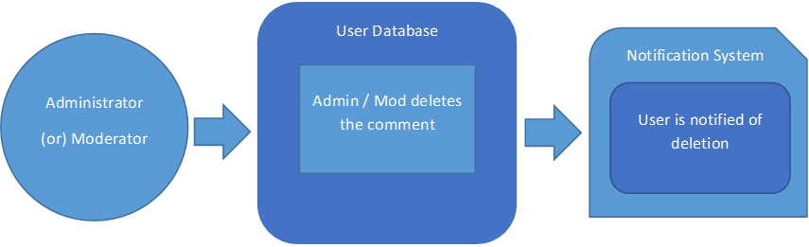

Notification System

User Database

Admin / Mod deletes the comment

User is notified of deletion

Notification System

User Database

Admin flags user as banned

User is notified of ban and whether or not they can appeal